A.Kamalesh

E0121038

1]

Background layers for the map

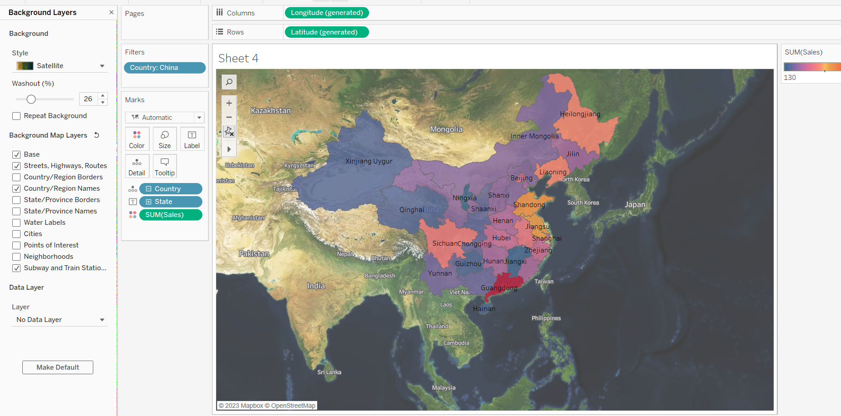

2]

Grouping the states by different names

